2-Wire VT02000A-2
User's Manual
Table of Contents
1 Product Overview•••••
1 .1 List of Models , 03
1 .2 Structu • 03
1 .2.1 Dimens•on 03
1 .2.2 Front — 04
1 .2.3 Rear Panel 04
1 .3 System Networking 05
1 .3. 1 One—to—One Scene- — 05
1 .3.2 Group Ca I Scene•• 05 2 Install VTO...
2.1 Direct Installation 07
- 1 . 1 Screw- 07
  - .2 Dimens•on -07
  - .3 Installation Step 08
  - Embedded in Wa I 09
  - 1 Screw- 09
    - Dimens•on 09
    - Instal ation Step 09
  - Wir•ng • 1 1
  - E ectric Control Lock and E ectromagnet•c Lock"
    - Electr•c Control Lock- . 12
    - Electromagnetic Lock••
- Installation Debugging •
  - WEB Setup. . 14
  - General Config, . 15
- Web Config •
4.1 System Config,
4.1 .1 Local Config
4.1 .2 LAN Config . 18
4.1 .3 Indoor Manager, . 18
4.1 .4 Network Conf g . 19
4.1 .5 Video Set . 19
  - .6 User Manage • .20

  - Info Search, 21
    - Call History 21
    - A arm Record 21
  - Status Statistics 22
    - VTH Status. 22
  - Logou 22
- Basic Function Introduction •
  - Call Function••• 23
5.1 .1 Call Manager Center • 23
5.1 .2 Call 23
  - .3 Group Call- 24
  - 27
  - Unlock Function- — 27
  - Compensation of L •ght••• 27
  - Vandal Proof••• 27
  - Restore Backup, 27
- FAQ....
Appendix 1 Technical Specifications
Appendix 2 Technical
Appendix 2.1 Cable Specificat on- .30
Appendix 2.2 Power Extension L ne Specif cation•• .30
Appendix 2.3 Embedded Box, .30
Appendix 3 VTMS••••
Appendix 4 VTMS Client
Appendix 4.1 Conf •g Network Address, .33
Appendix 4.2 Create Organization .35
Appendix 5 Toxic or Hazardous Materials or

1.1 List of Models
Model | Chassis Material | Color | Unlock via IC card | Button Type | Lock Control Module
VT02000A-2 | Metal | Silver | N/A | Mechan ca key | Bui t—in

1.2 Structure

1.2.1 Dimension
Important Safeguards and Warnings
Thank P ease read the following safeguards and warn •ngs careful y before us•ng the product in order to avoid damages and losses. Note:
Do not expose the dev•ce to lampblack, steam or dust. Otherwise it may cause fire or e ectr c shock.
Do not install the device at position exposed to sunlight or in high temperature.
Temperature rise in device may cause fire.
Do not expose the dev•ce to humid environment. Otherw•se •t may cause fire. The device must be installed on sol d and flat surface in order to guarantee safety under load and earthquake. Otherwise, it may cause device to fal off or turnover.
Do not place the dev•ce on carpet or quilt.
Do not block vent of the device or ventilation around the device. Otherwise, temperature in device wil rise and may cause fire.
Do not place any object on the device.
Do not disassemble the device without professiona instruction. Warning:
Please use battery properly to avoid fire, explosion and other dangers.
Please rep ace used battery w•th battery of the same type.
Do not use power line other than the one specified. Please use •t properly.
Otherwise, it may cause f re or electric shock.
Special Announcement
This manual is for reference only.
A the designs and software here are subject to change without pr or written notice.
A I trademarks and reg•stered trademarks are the properties of the•r respective owners.
• If there is any uncertainty or controversy, please refer to the final explanation of us.
P ease visit our webs te for more information.
Before you install the device, please make sure you know the dimension of device and select appropriate nsta ation method. See Figure 1 — 1
129M  140m - o - o | 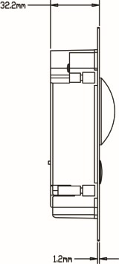
Figure 1 — 1

1.2.2 Front Panel
No. | Component Name | Note
 | Camera Angle Adjustment | Adjust camera angle.
2 | Vandal—proof Switch | When VTO if forced to eave wall, it WII a arm and report o MGT center.
3 | User Port | Connect to lock, door sensor feedback and unlock button.
4 | Project Port | Reserved for project staff use.

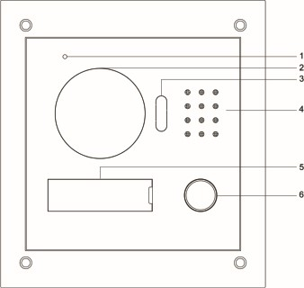
1.3 System Networking
This chapter mainly •ntroduces usage of digital VTO, please read the following content and instal the device according to your actual condition.
Figure 1— 2
No. | Port Name | Note
 | MIC | Aud o n ut.
2 | Camera | It mon tors correspond'ng door region.
3 | Compensation Cght | Light compensation will automat cally turn on during monitoring, call'ng, or connecting status if there s no enough light in environment.
4 | Speaker | Aud o output.
5 | User Nameplate | Display username and other info.  I center or VT H.
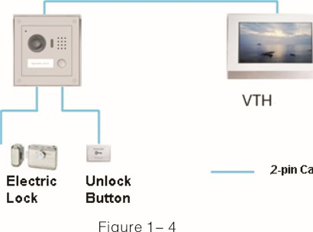
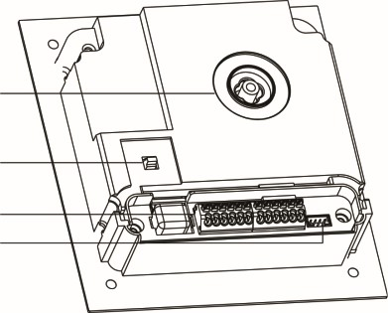
1.3.1 One—to—One Scene
Cable
Figure
Door
Sensor
Lock
V s tor press Call button to call residence (as VT H) or Center. See F gure 1 — 4.
6 Call Button Ca
1.2.3 Rear Panel
1

1.3.2 Group Call Scene
When visitor press Ca I button on VT O, mu tip e VTHs wi I ring at the same time. User
2
can call, hang up, and unlock on any of these VTHs.
3Note:
4VT H has 1 master VT H and up to 3 extension VTHs. See Figure 1— 5.
Figure 1— 3

4)6)

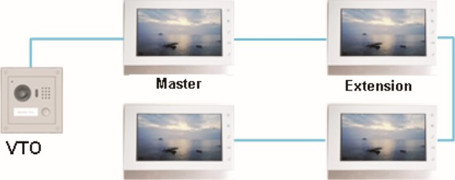
2.1 Direct Installation
2.1.1 Screw
Before installing VT H, please check screws on accessory bag according to the following spec fications and install by fol owing this guide.
Component Name | Illustration | Quantity
M3 x 6 Hex slot pan head tail mach ne screws galvanizing wh te |  | 4
M3 x 8 Cross recessed countersunk head tail machine screws — — galvan•zing white |  | 4
ST3 x 18 Cross recessed countersunk head tail tapping screws ga vanizing white  tube 6 x 30mm | 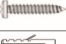 | 4  4
Extension Extension
2-pin Cable
Figure 1— 5
White expansion
Chart 2—1 Note:
M3x6 or M3x8 either is OK.

2.1.2 Dimension
Before you •nstall the device, please make sure you know the dimension of dev•ce and se ect appropriate insta lat•on method. See Figure 2— 1 .
0 | 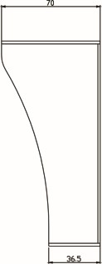
F gure 2— 1
(6)

2.1.3 Installation Step
Step 1 Install metal bracket into the groove on wall. At spot 1 fasten screw (ST 3 x 18 Cross recessed countersunk head tail tapping screws galvanizing white), and fix metal bracket on wall. See Figure 2— 2
Step 2 Align the device on metal bracket according to screw hole. At spot 2 fasten screw (M3 x 8 Cross recessed countersunk head tai mach'ne screws — galvanizing white), and fix dev ce on metal bracket. See F gure 2— 3.
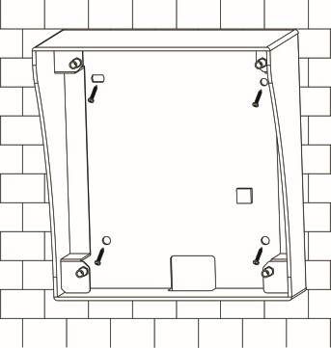
Figure 2—2
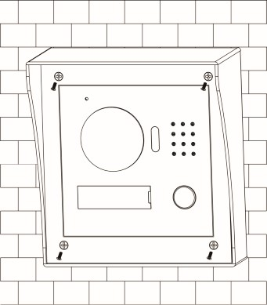
Figure 2—3

2.2 Embedded in Wall
2.2.1 Screw
Before installing VT H, please check screws on accessory bag according to the following spec 'fications and install by fol owing this guide.
Component | Illustration | Quantity
M3 x 6 Hex s ot pan head tail mach'ne screws galvanizing wh te |  | 4
M3 x 8 Cross recessed countersunk head tail machine screws — — galvan•zing white |  | 4
Chart 2—2 Note:
M3x6 or M3x8 either is OK.

2.2.2 Dimension
Before you nstall the device, please make sure you know the dimension of dev•ce and se ect appropriate insta lat•on method. See Figure 2— 4.
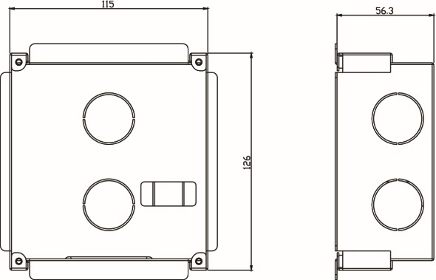
Figure 2—4

2.2.3 Installation Step
Step 1 Dg a hole on wall, its dimension is 117* 128*80(mm).See Figure 2— 5.
Step 2 Embed metal bracket into wall until its four peaks lean against the wal . See F gure 2— 6.

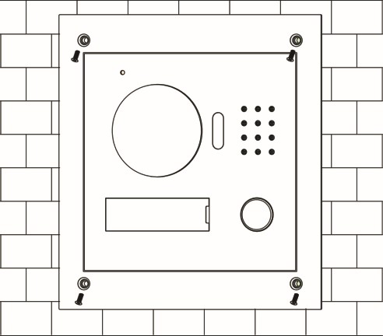
Step 3 A ign the device on metal bracket according to screw hole. At 2 spots fasten screws (M3 x 8 Cross recessed countersunk head tail machine screws ga vanizing white), and f x dev ce on metal bracket. See Figure 2— 7.

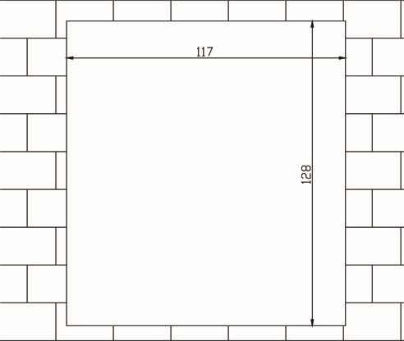
Figure 2—7

2.3 Wiring
Figure 2—5 See Figure 2— 8.
No. | Component Name | Note
 | User Port | Power supp y, connect to lock, door sensor and unlock button.
2 | Project Port | Reserved for project staff use.
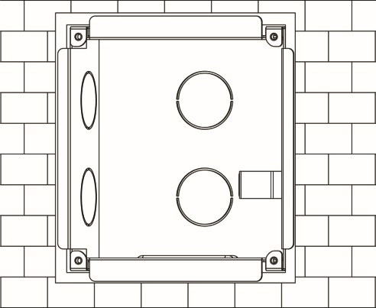
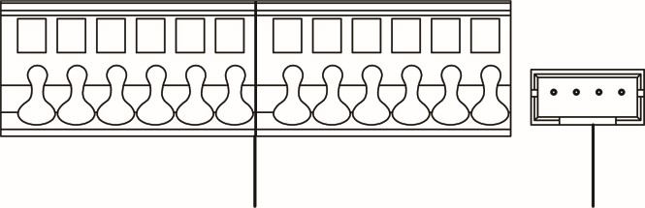
1 2

Fgure 2—8
2—6

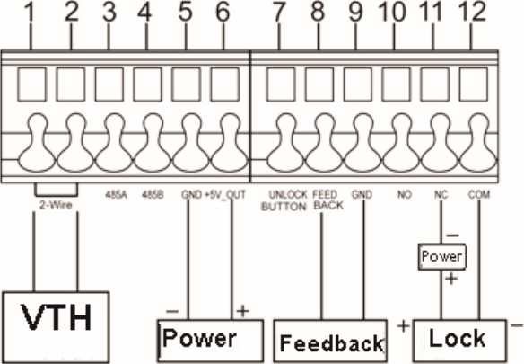
2.4 Electric Control Lock and Electromagnetic Lock

2.4.1 Electric Control Lock
When VTO connects to e ectric control lock, it means that the pos•tive end of electronic contro lock connects to NO of VTO (user port 10) whi e its negat ve end connects to COM of VTO (user port 12).
When VTO connects to unlock button, one end of unlock button connects to
UNLOCK BUTTON of VTO (user port 7) while the other end connects to GND of
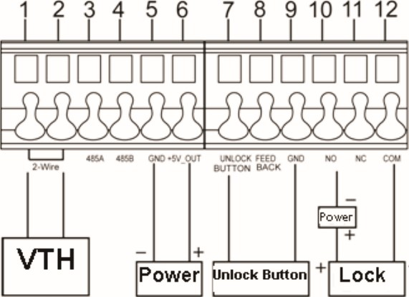 Figure 2—10
VTO
(user
port
9).
See
Figure
2—
9.
Figure
2—9

2.4.2 Electromagnetic Lock
When VTO connects to electromagnetic lock, it means that the positive end of electromagnetic ock connects to NC of VTO (user port 1 1) while its negative end connects to COM of VTO (user port 12).
When VTO connects to door sensor in electromagnetic lock, one end of door sensor connects to FEEDBACK of VTO (user port 8) while the other end connects to GND of VTO (user port 9). See Figure 2— 10.
49

Warning:
- Before debugg•ng, the staff shall be familiar with device' s installation, wiring and usage.
- Before debugg•ng, check wiring for short or open circuit.
- When staff find each c•rcuit s normal, p ug the device to power. After debugging, clear the site.

3.1 WEB Setup
If you first use VTO, you may need to operate according to the fol owing steps:
Step 1 First, make sure your PC and the VTO are we I connected, and follow steps below to login WEB interface.
Step 2 In Internet Explorer, •nput IP address of the VT O, and press Enter. System shows Figure 3— 1.
Step 3 Input Username and Password. Step 4 Click on Log•n.
Note:
Default IP address of VTO is 192.168.1 .1 10. Default username and password is admin/adm n. After first login, p ease change your password.
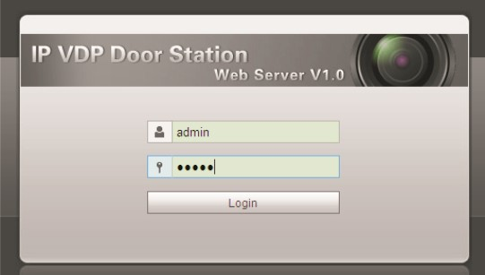
3—1

3.2 General Config
If you first use VTO, you may need to operate according to the following steps:
Step 1 In Internet Explorer, input P address of the VTO, and press Enter.
Note:
Default IP address of VTO is 192.168.1 .1 10. Default username and password is admin/admin. After first log•n, please change your password.
Step 2 In WEB interface, se ect System Config>Local Config, set video format as WVGA as in Figure 3— 2.
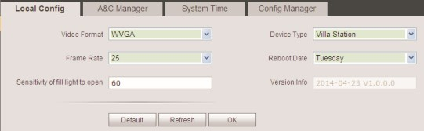
Figure 3—2
Step 3 In System Time tab, click on Sync PC to make VTO time the same with PC.
Step 4 Select System Config>Ne work Config, set VTO IP, Subnet Mask and Default Gateway. See Figure 3— 3.
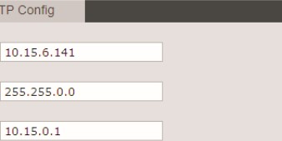
Network Config
FTP
Subnet
Mask
IP Address
Default Gateway
MAC Address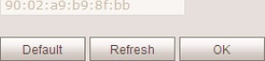
Figure 3—3
Step 5 (Optional) If VTO connects to VTMS platform, System Con ig>LAN Config, set Area No. Section No. Build ng No. and etc. These parameters must match settings on VT MS Client. P ease refer to Appendix 2 and 3. See F gure 3— 4.

LAN contig
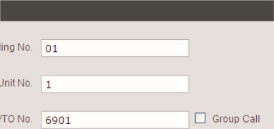
Building No.
VTO
Building Unit No.
This chapter introduces VTO WEB interface and its parameters, and hot to configure them.

4.1 System Config
Figure 3—4

4.1.1 Local Config
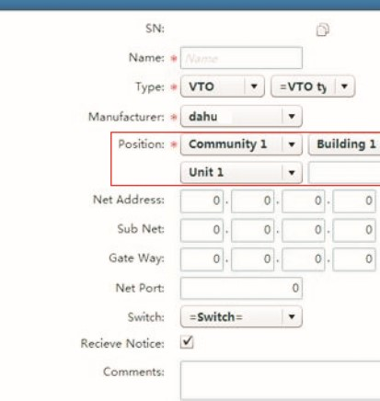 6901
 | —'l Save | ss Cancel
System Contig | Local Contig AAC Manager System Time Config Manager  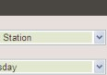  Type Villa Stat+
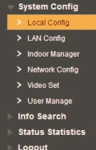 | 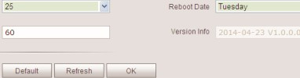  Frame Rate 25  Sensitjuty or ml liontto open 60
Parameter | Note
Video Format | Set video format that collected by the camera, including: WVGA and D WVGA resolut on is 800 x 480; DI resolution is 704 x 576.
Device Type | D splay device type.
Frame Rate | NTSC: 30 fps, PAL: 25 fps.
Reboot Date | On the set date, device wil automatica ly reboot.
Sensitivity o l' ght to open | Set threshold of ight.
Version Info | Dsplay device version info.
Default | On y restore current Local Config page to default sett ngs.
4.1.1.1 Local Config
In Local Config interface, you can view VTO model, version info and etc.
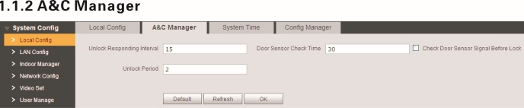
Figure 4—1
4.1.1.2
Figure 3—5
Note:

When you configue scene, different VT Os sha I have different VTO no. and same building no. and unit no., in order to form a proper network.
4—2
Parameter | Note
Unlock Responding  Interval | The interval between current unlock and next one, unit is second.
Unlock Period | Period door remains unlocked, unit is second.
Door Sensor Check Time | When only use door sensor, check" Check Door Sensor Signal Before Lock" , Set "Door Sensor Check T•me" to enab e •t. When door remains unlocked over set door sensor check time, it alarms.
Check Door Sens or Signal Before Lock
Fill in VT H info as user's name, VTH short no. and IP address.
Note:
VT H short no. cons•sts of four dig•ts, the first two digits can be within 01 —99, the last two digits can be within 01-16.
Note:
Parameters 'vv•th * are mandatory.

4.1.4 Network Config
Here you can set VTO IP address, Subnet Mask and Default Gateway.
After you have modified IP address, Web page will reboot and go to the new IP address
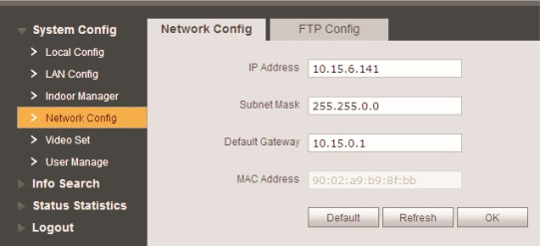
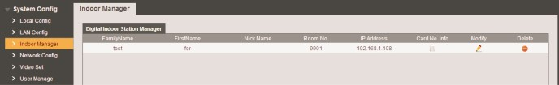
4.1.1.3 System Time web page. See Figure 4- 5. Here you can set date format, time format, and input system date and time. You can also cl'ck on Sync PC to synchronize system t'me with PC time.
4.1.2 LAN Config
Here you can register VTO to center and set how to call center. Please refer to Ch 5.1 .1.

4.1.3 Indoor Manager
In Indoor Manager interface, you can add VTH (digital indoor station), view VT H info and delete VTH.
Figure 4—5

4.1.5 Video Set
Figure 4—3 You can set video effect and volume in Video Set interface. See Figure 4- 6. Add VTH
Add
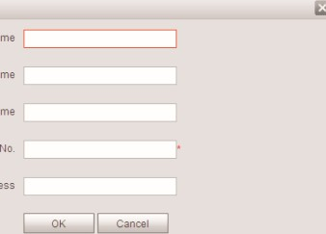
FamilyName
Firstname
Nick Name
VTH Short
IP Address
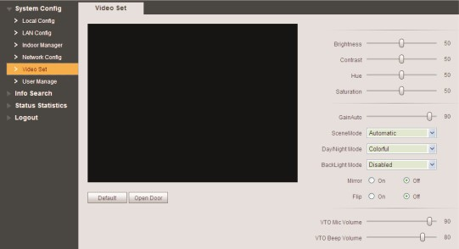
In Indoor Manager interface, click on Add. The system pops up a window as in Figure 4-4.
4—6

Parameter |  | Note
Gain |  | Gain lim•t of video basic parameter.
Scene Mode |  | Select mode: automat c, sunny, night and etc.
Day/Night Mode |  | Color mode.
Back Li ht Mode |  | Backli ht for s ecial env ronment.
Mirror |  | Make •mage cfsplayed in mirror.
 |  | Display mage in flip.
VTO Mic Vo ume |  | Set VTO MIC volume size.
VTO Beep Volume |  | Set VTO beep volume size.
Default |  | Reset video effect and volume to default.
Unlock Unlock via web.

4.1.6 User Manage
Only when you login as adm•n, you can add, modify, delete and view user info in User Manage interface.

• Add User
In User Manage interface, click on Add User, system pops up Figure 4- 7. F in user info.
Add User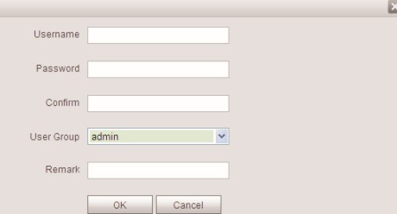
Figure 4—7

Modify User
In User Manage interface, c ick on , system pops up Mod'fy User interface. Check Change Password, and change password and remark, see Figure 4- 8.
Modify user
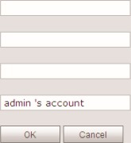
@ Change passworg Old Password
Remark
New Password
Confirm

Figure 4—8 Delete User
In User Manage interface, cl'ck on to delete user.

4.2 Info Search

4.2.1 Call History
Here you can Vew call history of VTO in Call History interface. It can save up to 1024 items.See Figure 4—9.
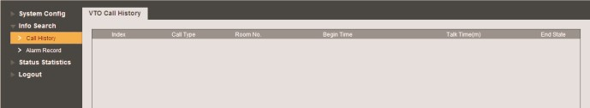
Figure 4—9

4.2.2 Alarm Record
You can search VTO alarm record on Alarm Record interface with storage up to 1024 items. See Figure 4- 10.
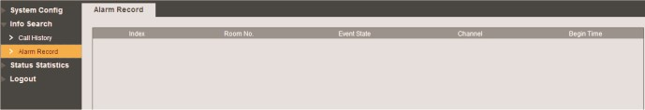
4—10

4.3 Status Statistics
4.3.1 VTH Status
Here you can view connection status of VT H.

• Delete User
Offline: VTO and VT H are not connected, you cannot call, monitor, talk or etc.
Online: VTO and VTH are connected, you can call, monitor, talk and etc.

5.1 Call Function
- MON  - Unmon: VT H is not monitoring. Onmom: VTH is monitoring.  See Figure 4- 1 1 . | 5.1.1 Call Manager Center  Check Register to the MGT Center, you can touch the Call button to cal manager center. Now VTO can only cal MGT Center, cannot call VTH. Manager center's time can be set on management p atform or vil a VTO's web-end. Once manager center picks up the call, you can perform a visual bidirectional talk w•th the manager center.
Status
Figure 4—1 1  4.4 Logout  Here you can reboot device or logout. | Step 2 In LAN Config, check register to the MGT center, as in Figure 5—1.  Step 3 Fill in MGT center IP address and MGT port no.  Step 4 Set cal VT S time. W thin th s per•od, VTO can on y ca I the center.  Step 5 Check Cal VT S or not.  Step 6 Confirm all config, and cl ^{u} ck on OK. Enter Logout Reboot Devices, to manually
You can touch the button on VTO to end cal at any time.
Step 1 According to VTO conf gured for the center, fill in building no, build'ng unit no. and VTO no.
Click on logout to log out the system and it returns to login page. reboot the device.
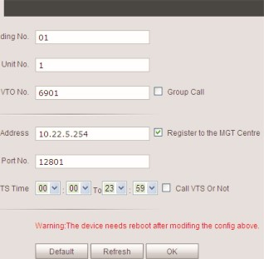
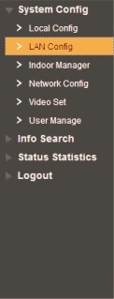
LAN Config
Building
MGT
call
vTS
Building unit
v,'GT centre IF
Figure 5—1

5.1.2 Call User
Press Call button under standby status, and the VTO wil call user. User may monitor VTO from VTH.

- On VT H, press Unlock button to unlock door.
- When VT H p•cks up, you can start talk with the VT H.
- If no one answers the call, then the call will end automatically and device returns to standby status.
5.1.3 Group Call
Group call is mainly used for one VTO. Press Call button on VTO to cal mult•ple VT H at the same time.
VT H consists of master VTH and extension VT H. A system can only have a max of 1 master VTH and 5 extenSon VTHs. Please refer to VT02000A Series Instal ation Guide V 1 .0.0.

Set VTO
Step 1 Select System Config>lndoor Stat on Manager, system shows Indoor Stat on interface.
Step 2 In Indoor Station Manager interface, click one to delete default VT H.
Step 3 Cl'ck on Add, input VT H Short No., IP Address (optional) to add a VT H. See Figure 5— 2.
Note:
In Indoor Station interface, you only need to add main VT H, and you do not need to add extension.
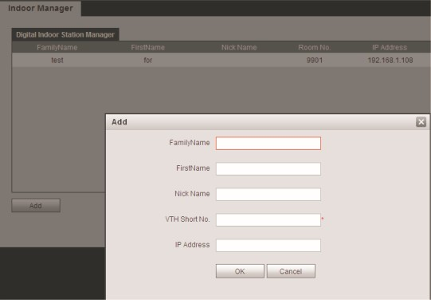
Fgure 5—2 Note:
Paramete with * are mandantory to be set.
Step 4 In LAN Config in erface, check Group Ca l, and click on OK. See Fgure 5—3. Step 5 After config is comp ete, enter Logout interface to reboot VTO.
System Contig  > Local Config | LAN Config  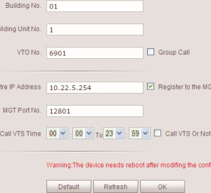  Building  MGT  centre  MGT  centre  contig  above
> Manager
> Set
Manage
Into Search
Status Statistics
Logout
Figure 5—3
Set Main VTH
Step 1 On VT H screen, press System Set •ngs>Project Sett•ngs, input password (default is 002236) to enter Project Settings interface.
Step 2 Press Product Info, •nput Room No., Loca IP and etc as in Figure 5— 4.
Note:
Room No. must match setting in VT H Short No. In Figure 5—4.
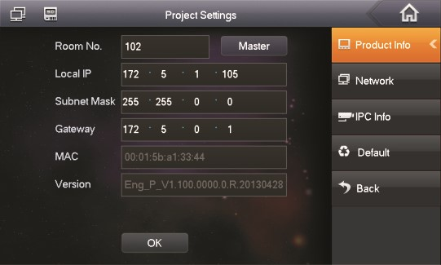
Figure 5—4
Step 4 Press Network, input VTO IP Address. See Fgure 5— 5.
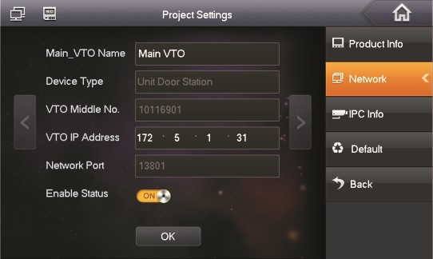
Figure 5—5
Set Extension
Step 1 On VT H screen, press System Settings>Project Settings, nput password (default is 002236) to enter Project Sett ngs interface.
Step 2 Press Product Info. Press Master, Master icon becomes Extention icon.
Step 3 Set Room No. (i.e. 1 101—1), input IP Address, Subnet Mask and Gateway. Step 4 In Master IP, input IP of the ma n VT H. After competion, extension wil automatica ly sync with ma n VT H info conf gured by user. See Fgure 5— 6.
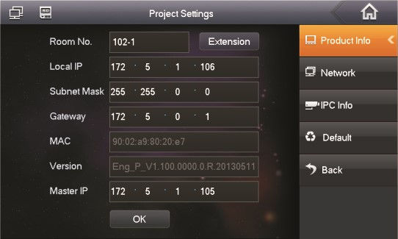
Figure 5—6

5.2 Monitor
Both VTS and VT H are able to monitor this VTO by enabling the camera to capture local circumstance. 5.3 Unlock Function
Unlock by Center
When center is called, calling or monitoring, center can remotely unlock door. VTO wi I return to standby interface after call ends or countdown stops.
Unlock by VTH
When VT H •s called, calling or monitoring, VT H can remotely unlock door. VTO will return to standby interface after cal ends or countdown stops.

5.4 Compensation of Light
In dark environment or at night, the VTO adopts auto photoreception technology which achieves light compensation •n connecting status.

5.5 Vandal Proof
There •s one channe of vandal proof which wil generate alarm sound and report to the manager center once VTO is forced to leave the wall.

5.6 Restore Backup
Restore Card Info
If you encounter abnormality with card info or accidently restore defau t settings, you can restore card info with this function.
Restore VT H Info
If VT H info is mistakenly changed, you can restore VT H info with this function. Note:
Every half hour, VTO automatically saves card and VT H info in the system. If you want to restore card and/or VT H info, you must restore within half hour after your last operat•on that change these info.

Appendix 1 Technical Specifications

FAQ
1 . Q: I pressed Call button, and the indicator turned on, but the VTO did not start a call? | Model |  | VT02000A-2
A: Please check your operation process. | System | Main Process | Embedded micro controller
2. Q: How to end a call when I am calling? |  | os | Embedded Linux os
A: Please press button on VTO and there will be sound from the device. |  | Video Compression Standard | H.264
3. Q: The device could not boot up and there was no sound or light. | Video | Input/Sensor | Megapixel CMOS HD camera
A: Please check if power supply is well plugged. |  | Night Vision | Support
4.Q: My call did not go though. |  | Input | Omnidirectional Mic
A: It is network connection error; please check the cables of the device and its extension. | Audio | Output | Built—in speaker
 |  | Talk | Support bidirectional talk
5. Q: I have other problems not included above. | Operation | Input | Single key input
A: Please contact technical staffs for assistance.
 | Mode | Door Lock Status Check | Support (optional)
 | Network | Ethernet | IOM/ 1 OOMbps self—fit
 |  | Network Protocol | TCP/IP
 |  | Power | DC 24V
 |  | Consumption | Standby < IW; working < 7W
 | General | Working Temperature | - 30⁰C +600
 |  | Relative Humidity | - 90 ⁰/0RH
 |  | Dimension (L x W x H) | 129.9mm x 32.2mm x 140mm
 |  | Weight | 0.8kg

Appendix 2 Technical Specifications

Appendix 2.1 Cable Specification
The wir•ng ength between VTO and VTH is I_N, so reasonable specfication of wir•ng is:
Cable Specification
UT P Cat5e/Cat6: 10 ohm/ 100m | Optional | Optiona
UT? Ca 5e/Cat6: 18.8 ohm/100m | Not op ional | Not optional
Note:
Please do not et LN be over 100m.

Appendix 2.2 Power Extension Line Specification
The wiring length between VTO and adaptor •s Lc, so reasonable specification of extnsion line is:
Extension Line Specification | 30m | 100m
20AWG | Optional | Not optional
18AWG | Optional | Optiona
17AWG | Optional | Optiona
Note:
Before plugging extension line to power, make sure its positive and negative end are correctly wired.

Appendix 2.3 Embedded Box
VTO Model |  | Embedded Box
VT02000A-2 |  | Case 126*115
 | Appendix 3 VTMS

Check Installation Environment
This manual makes W'ndow XP as example to •ntroduce how to modify IP of PC inorder to connect VTMS and monitoirng system.
Step 1 Se ect Start>Contro Panel>Network Connection>Loca Area Connection, right click on Local Area Connection icem. select Prooerties. see Appendix 3— 1.
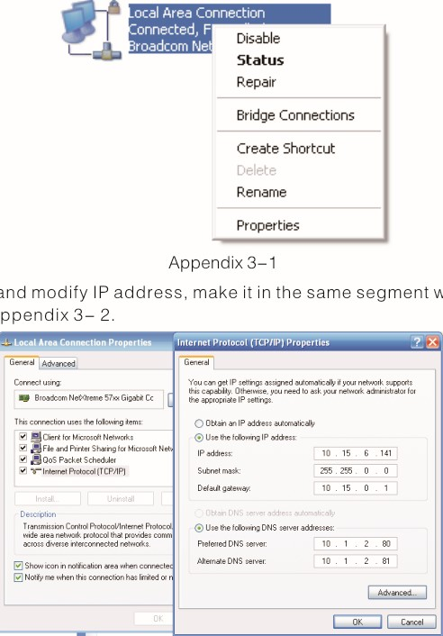
Step
2
View
and
w
th
VT
O.
See
Appendix
3—2

Appendix 4 VT MS Client
Step 3 After complete modification, select Start>Run, inpu "cmd" , cl ^{u} ck on OK. Enter command interface, input "ping" + IP of the VTO. If it obtains commun•cation data, then VTO and the PC are connected. See Appendix 3— 3.
 | c:WNDOWSksFtam3awnd.en
 | cc) copyright : | XP  1985-2001 | nicrosoft | corp.
 | NDocmntc
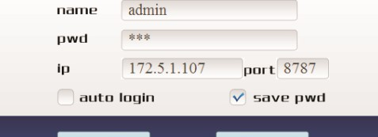
Louin
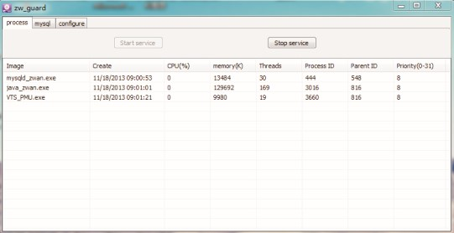
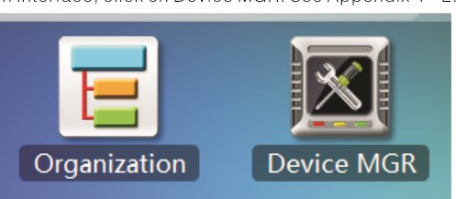
This following manly introducts how to config VTMS Client.

Appendix 4.1 Config Network Address
Step 1 Install VTMS C ient on PC.
Step 2 Double c •ck on , •n pop—up box input username, password, IP address, port and etc. Click on Login. See Appendix 4— 1 .
Note:
Default username and password is admin and 123, respectively. After first successful login, please change password.
Appendix 3—3

• Enable VTMS
The following mainly •ntroduces how to config VTMS for you to login VTO and use VTMS.
step 1 Install VTMS on PC.
Step 2 Double click on , click on , Start service, and VT MS wi I boot up.
Appendx 4— 1
Step 3 In main interface, click on Device MGR. See Appendix 4— 2
Appendix 3—4
4—2
$2$9

Step 4 Double click on VT S parameter collumn, sustem pops up Edit device box, input PC' S IP address. See Append'x4— 3.
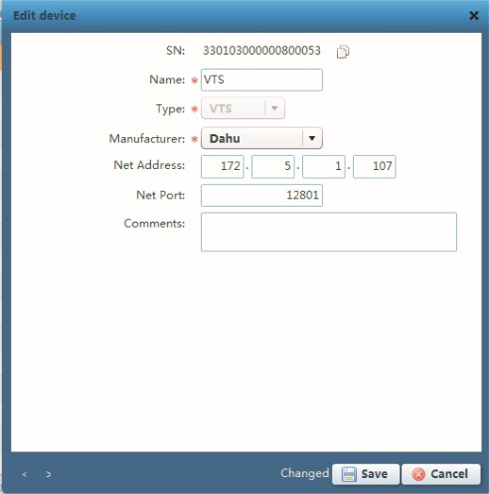
Appendix 4—3
Step 5 Click on Save. Input project password (default project password is 123).
Step 6 Re—login VTMS, you can see VTMS is successfully configured as in
Appendix 4— 4.
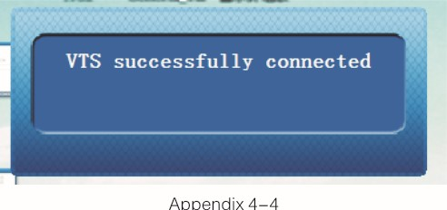
Appendix

Appendix 4.2 Create Organization
First you must bui d up environmrnt and set VT MS server, please refer to Appendix 3. This chapter takes example of a residence with 10 bui dings and 2 un•ts.

Create Residence Organization
Step 1 In VTMS main •nterface, select Organization, click on Batch Add. System pops up Batch Add box, see Appendix 4— 5.
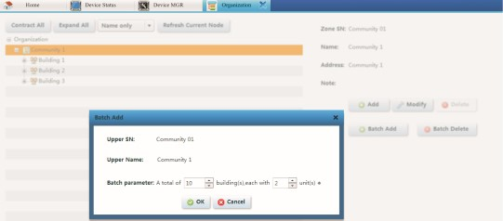

Appendix 4—5
Step 2 Click on OK to save. The created organization is as in Appendix 4— 6.
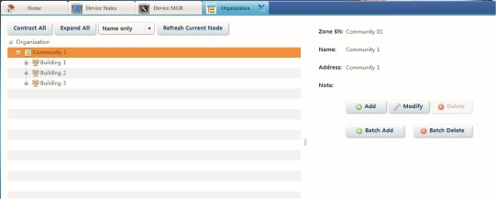
Appendix 4—6

. Add VTO
Step 1 In VTMS main •nterface, select Dev ce MGR, cl Ck on Add, system pops up Batch Add box.
Step 2 Fill in info according to your actual condi ion, and click on Save. See 4— 7.

25

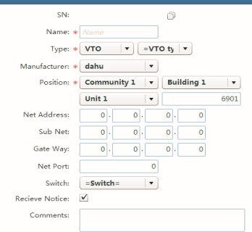
Type location cant be Changed after saving
Appendx 4—7
Add VTH
Step I In VT MS main interface, select Device MGR, click on Batch Add, system pops up Batch Add box.
Step 2 Fill in info according to your actua condition, and c ick on Save. See Appendix 4— 8.

Appendix 5 Toxic or Hazardous Materials or Elements
Component Name |  | Toxic or Hazardous Materials or Elements  Hg Cd
C'rcuit Board Component | o | O | O | O | PBB  o | PBDE  o
Device case | o | o | O | O
and Cable | o | O | O | O
Packing Components | o | O | o | O
Accessoöes | O | O |  |  | O | O
O: Indicates that the concentration of the hazardous substance 'n al homogeneous materials in the parts is below the relevant threshold of the SJ/TI 1363—2006 standard,
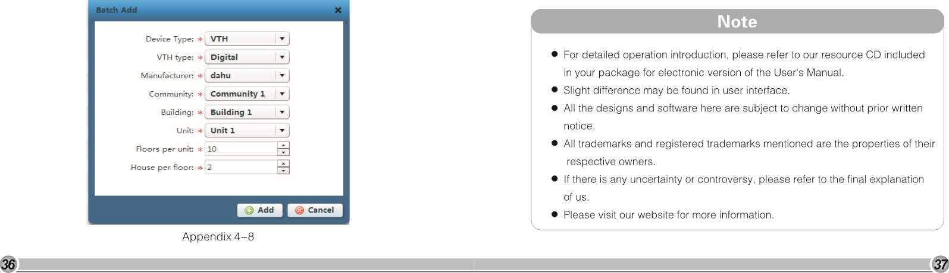
X: Indicates that the concentration of the hazardous substance of at least one of a I homogeneous mater •als in the parts is above the relevant hreshold of the SJ/TI 1363— 2006 standard. During the environmental friend y use period (EFLJP) period, the toxic or hazardous substance or e ements contained in products will not eak or mutate so that the use of these (substances or elements) will not result in any severe environmental pollution, any bodily •njury or damage to any assets. The consumer is not authorized to process such kind of substances or elements, please return to the corresponding local authorities to process according to your local government statutes.
For detalled operation introduction, please refer to our resource CD inc uded in your package for electronic version of the User's Manual,
Slight difference may be found in user interface.
- All the designs and software here are subject to change without prior written notice.
- All trademarks and registered trademarks mentioned are the properties of their respect ^{i} ve owners.
If there 's any uncertainty or controversy, please refer to the final explanat'on of us.
- Please visit our website for more information.

